Howard University
College of Engineering and Architecture
Department of Electrical Engineering & Computer Science

Large Scale Programming
Fall 2024

Midterm Exam – Part I
October 17, 2024

Part I: 50 pts. (essay questions)

Instructions:
- Submit completed exam to your github repository under package org.howard.edu.lsp.midterm

Verify that the commit(s) completed successfully

- OPEN BOOK, OPEN NOTES. THERE IS NO COLLABORATION ON THIS EXAM
- Site any and ALL references for anything obtained off the internet.

Question 1. (10 pts.)

You are reviewing the following class in a Fitness Tracking System. The class is intended to manage various aspects of a user’s fitness activities.

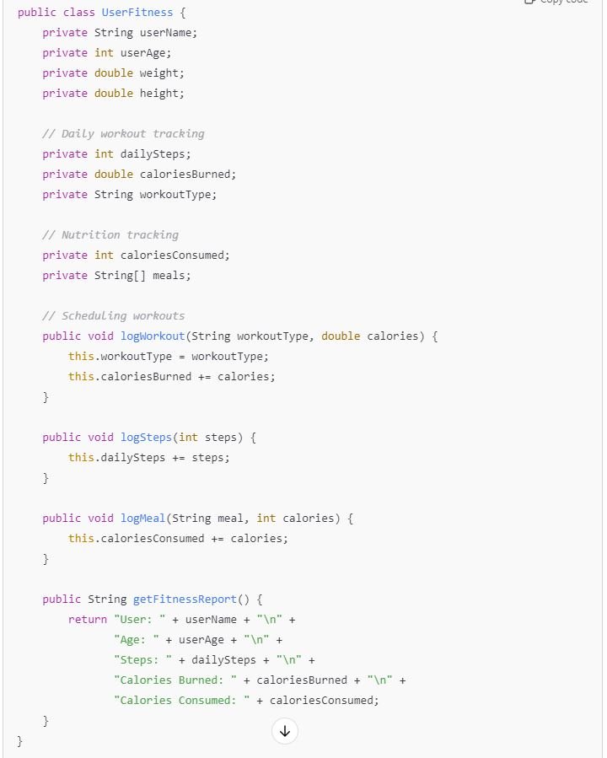

Tasks:
- Analyze the UserFitness class. Explain why this class has low cohesion. (5 pts.)
- Cohesion refers to how strongly related the different components in a class are. Since the class is performing many different tasks, such as workout scheduling, calorie tracking and step count, and is not focused on one aspect of fitness it is low cohesion.
- GeeksforGeeks. (2022, July 5). Cohesion in Java. https://www.geeksforgeeks.org/cohesion-in-java/

- Describe, in general, how you would split the UserFitness class into more cohesive classes. Your answer should not be a complete design. (5 pts.)
- To make the class more cohesive, it could be separated into workoutStats which would track the user’s daily exercises and step count, nutrition Stats, to calculate calories consumed, and a fitnessReport class that draws information from the previous two classes to create a comprehensive report.

Question 2. (5 pts.)
Given the following, answer the below questions.

A university manages its students using a program that has a class Student with subclasses FirstYear, SecondYear, and ThirdYear for year-specific state and behaviors. The program has a List that contains all Students.

Should Student be a class, an abstract class or an interface? Explain your answer
- Students should be an abstract class since it contains more than one abstract methods. Student does not need to be instantiated instantly, since they are subclassed into first second and third years.

- At the end of each year, the third-year students graduate and must be removed. This is done by passing the list to the following method:

void removeThirdYears(List<Students> students) {
for (Student student : students) {
try {
ThirdYear = (ThirdYear) student;
students.remove(thirdyear);
}
}
}

- Why is the above method flawed? Hint: Another Arthur Riel heuristic (5 pts.)
- The method is trying to make every student a ThirdYear, which will throw an exception if the student isn’t a Third Year student, additionally, a list cannot be modified in this manner. The heuristic “A class should not have more than one reason to change: is being violated since there is iteration and modification taking place in one method.

- Gillis, A. S. (2023, February 22). What is an abstract class?: Definition from TechTarget. TheServerSide.com. https://www.theserverside.com/definition/abstract-class
- Mancl, D. (n.d.). OO design heuristics. https://manclswx.com/talks/top_heuristics.html

Question 3. (5 pts.)
Given the following, answer the below questions.

public class BankAccount {
public String accountHolderName;
public String accountNumber;
public double balance;
public double interestRate;

public BankAccount(
String accountHolderName,
String accountNumber,
double initialDeposit,
double interestRate) {
this.accountHolderName = accountHolderName;
this.accountNumber = accountNumber;
this.balance = initialDeposit;
this.interestRate = interestRate;
}

// Exposed implementation for adding interest
public void addInterest() {
double interest = balance * (interestRate / 100);
balance += interest;
}

// Exposed implementation for deposits
public void deposit(double amount) {
balance += amount;
}

// Exposed implementation for withdrawals
public void withdraw(double amount) {
balance -= amount;
}
}

- Is BankAccount well-encapsulated? Why or why not? If so, describe what changes you would make to the class. Otherwise, state nothing. (5 pts.)

It is not well-encapsulated , since access is not restricted to private access. For better encapsulation, the variables should be declared privately, and get/set methods should be implemented publicly so that the class can be interacted with this way.

Question 4. (10 pts.)
Given the following, answer the below questions.

Given:
A car manufacturer uses Java software to track current vehicles being built. The UML diagram below shows an excerpt of the current software structure. You should assume the presence of other appropriate fields and methods

Car
getTrimLevel()
Engine
accelerate()
getFuelLevel()
Base
Sports
Luxury
Electric
Petrol

Each car can be built to one of three trim levels: Base, Luxury or Sport. They can also be configured with an electric or petrol engine. At various points in the manufacturing process the customer can choose to change the trim level.

Task:
- Explain in detail why the current structure does not support this. (5 pts.)
- After a Car object is instantiated, the trim cannot be changed because inheritance is static. The object would have to be deleted and re-instantiated to change the subclass.

- Describe how to refactor the structure to allow trim-level change for a car to dynamically change. Hint: How would you modify Car to use composition to solve the problem? (5 pts.)
- By making trimLevel a separate class, instead of a subclass, it can be assigned to car instead of being set at instantiation. The class car is now more dynamic and the new class can be reused across different instances of Car.

Question 5. (5 pts.)
Suppose you are about to code a particular class and find that you have written another class with nearly the functionality that you now are developing. This means that the two classes in large parts contain the same code, but in smaller parts have different code. Explain in detail why this may be a problem and how to solve it. Give your answer in terms of Arthur Riel’s design heuristics.
- Since both classes have similar code, it will violate the minimize redundancy heuristic. Duplication of code will make it harder to maintain since any changes must be made multiple times. Additionally, the code is not reusable because it was not properly abstracted – if the code was written is a way that modules could be implemented elsewhere, it would be easier to expand.

- Mancl, D. (n.d.). OO design heuristics. https://manclswx.com/talks/top_heuristics.html

Question 6. (5 pts.)
Suppose we need to store instances of the classes Car and BankAccount in a database. To obtain low coupling it may seem as if the functionality to save an instance should be in precisely those classes, since they have the information that shall be saved. Why is it unwise to place the database calls there?
- With low coupling, instances should have as little to do with each other as possible (low dependency), but classes should only have one responsibility, adding the functionality to save instances in the classes would violate this rule.

Question 7. (5 pts.)
Given a set of requirements, what conditions must be met to make it appropriate to create a new class hierarchy using inheritance? Neither superclass nor subclass exist before, the question is about designing a new class hierarchy.
- The classes should have a clear relationship, shared behaviour(similar methods) and shared attributes.

Question 8. (2.5 pts.)
Describe the difference between inheritance and composition why would you choose one over the other.
- In inheritance, methods and other properties are derived from parent classes, it increases reusability since information can be shared among subclasses. Composition is where objects from different classes are referenced in each other, allowing the functionality to be used without inheritance. Composition is used to avoid the structure of inheritance while being able to use functions derived elsewhere.

Question 9. (2.5 pts.)
Explain the meaning of cohesion and describe whether low or high cohesion is better.
- Cohesion refers to how strong the relationship between elements in a module are. High cohesion is better since it implies that classes are performing a focused purpose, and therefore are easier to maintain. Low cohesion is where a class performs lots of loosely connected functions.

